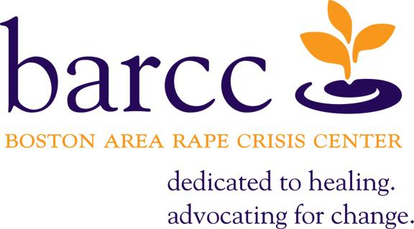

OFFICE SUPPORT VOLUNTEER APPLICATION

Welcome to the Boston Area Rape Crisis Center! The following is an application form to be filled out by each person interested in volunteering for the BARCC Office Support volunteer program. Please read each question carefully and answer in full.
Date: ___________________
Name: ________________________________________________
Mailing Address: ___________________________________________________________________
Number Street City State Zip
Phone: _____________________
May we leave identifying voicemails at this number? □ Yes □ No

E-mail Address: ________________________________________

Are you able to make at least a three-month commitment to volunteering with BARCC at this time? Please consider your plans for the coming months (e.g.: applying to school, moving, etc.)
□ Yes □ No If no, please inquire about one-time volunteer opportunities (volunteer@barcc.org) instead of completing this application.

Are you able to commit to one weekly in-office shift (see next page for possible shifts)?

□ Yes □ No If no, please inquire about one-time volunteer opportunities (volunteer@barcc.org) instead of completing this application.

On what date are you available to start volunteering (an approximation is fine)?

□____________________ □ As soon as possible

Do you know on what date you would need to stop volunteering (an approximation is fine)?

□____________________ □ I plan to stay indefinitely!

Which weekly shifts are you available to volunteer? Please check all that apply:

Monday: □ 9:15am-1:15pm □ 1:15-5:15pm □ 5:15-7:15pm

Tuesday: □ 9:15am-1:15pm □ 1:15-5:15pm □ 5:15-7:15pm

Wednesday: □ 9:15am-1:15pm □ 1:15-5:15pm □ 5:15-7:15pm

Thursday: □ 9:15am-1:15pm □ 1:15-5:15pm □ 5:15-7:15pm

Friday: □ 9:15am-1:15pm □ 1:15-5:15pm

(Please note: our offices are closed on public holidays)

Do you have any special needs? □ Yes □ No
If so, please list any accommodations that may be helpful or necessary. (We are currently wheelchair accessible and have a TTY.)

- Why are you interested in volunteering with the Office Support program at BARCC?

- How has rape affected your life? What does rape mean to you?

- What are your fears and/or concerns related to volunteering at BARCC?

- How do you handle conflict? Have you experienced conflict with a supervisor, co-worker or fellow volunteer? How did you handle this?

- One goal of our organization is to create and provide a safe and non-threatening environment. In thinking about how we provide such an environment, we reflect on all the different ways that a person, particularly someone who has experienced a sexual assault, may be made to feel disempowered. This includes our styles of communication and the ways in which we speak to people. Can you reflect on a time when your manner of communication may have been hurtful or disempowering to another person? Has anyone ever spoken to you about somehow changing the way you speak to others?

We do not require anyone to have a rape crisis background to join our center, but we welcome those who have had some prior experience. If you have done similar work through a rape crisis center or related organizations, please fill out the following:

Organization name:
Address:
Phone number:
Your supervisor:
Dates you were an active member:
How did you hear about BARCC?
□ Google search  □ Other search (Where?) ________________  □ Idealist.org  □ Received services | □ Volunteer, current  □ Volunteer, former  □ University/College (Where?) _______________________  □ Other _______________________
Do you have any questions or comments?

THANK YOU FOR YOUR INTEREST IN BARCC!

The Commonwealth of Massachusetts requires us to perform criminal record checks (CORI) on all incoming volunteers and interns. CORI checks are submitted at the time of an applicant’s interview. A finding does not necessarily disqualify someone from acceptance.

Some Guidelines for New Volunteers…

Volunteering at BARCC is a rewarding experience that brings all those involved into contact with the incredible strength and inspiration of survivors on almost every shift or speaking engagement. Those experiences are also often crisis situations that can be unpredictable and emotionally challenging for volunteers.

Many BARCC volunteers have a personal connection to issues of rape and sexual violence, often creating a strong sense of commitment to the cause. Volunteering at BARCC can be a wonderful experience for people, when the time is right for them.

How will I know if this is the right time for me to volunteer at BARCC ?

- It has been at least 1 year since you became personally connected to this issue.
- It has been at least 1 year since you have stopped receiving BARCC services (medical or legal advocacy, hotline, group or individual counseling).
- You receive counseling now, or have in the past, but do not feel a sense of crisis in your everyday life.
- You are not currently struggling with substance use.
- You have a strong support system in place.
- You feel 100% ready to be a BARCC volunteer.

